## **INTRODUCTION**

1. **INTRODUCTION OF THE PROJECT**

The project focuses on measuring key electrical parameters—namely voltage, current, resistance, power, and energy—in real time using an analog input source (such as a potentiometer) connected to an ADC-enabled microcontroller. By processing analog voltage values through the microcontroller’s ADC (Analog-to-Digital Converter), the system computes the corresponding resistance using the voltage divider principle and then derives current, power, and energy using standard electrical formulas (Ohm's Law and Power Law).

The measured and calculated data is transmitted over **serial communication** to a terminal software such as **Docklight** for real-time monitoring. In addition to wired communication, the project also incorporates **wireless data transmission** using a **Bluetooth module (BM71 XPro board)**, enabling the system to send data to a PC or mobile device. The received values can be graphically visualized using tools like the **Better Serial Plotter**, enhancing the real-time insight into how resistance and power parameters change as the potentiometer is varied.

1. **SCOPE OF THE PROJECT**

The scope of the project encompasses the development of embedded firmware capable of measuring real-time electrical parameters such as voltage, current, resistance, power, and energy using analog inputs. The firmware processes analog signals using the microcontroller's ADC and computes the derived parameters based on electrical laws.

The processed data is displayed through various communication interfaces, including **serial UART** (for tools like Docklight) and **Modbus RTU** protocols, enabling compatibility with industrial data logging systems. Additionally, the integration of **wireless communication using the BM71 Bluetooth module** extends the project’s scope to mobile and remote applications.

1. **LEARNING**
2. Bluetooth BLE BM71 XPro
3. Code Organisation
   1. Function and Header File
   2. Rules and Regulation
4. Software State Machine
5. MODBUS Interfacing
6. Understanding ADC operation and analog signal sampling
7. Working with voltage divider circuits
8. Real-time serial data communication UART
9. Firmware development using AVR (Microchip Studio)
10. Debugging using tools like Docklight.
11. Peripheral

## **COMPONENT**

1. **HARDWARE**
2. Arduino Mega 2560 Development Board
3. Potentiometer 100kOhm +- 1%
4. BM71 XPro BLE
5. Jumper Wires Connector (Male & Female)
6. USB HUB and TTL to USB Connector
7. **SOFTWARE**
8. Microchip studio Compiler
9. Docklight Monitor
10. Better Serial Plotter and Serial Port Plotter
11. MODBUS Server Software
12. 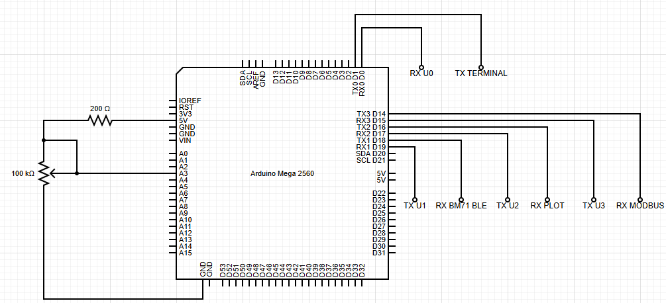**CIRCUIT DIAGRAM**
13. **OUTPUT**
14. 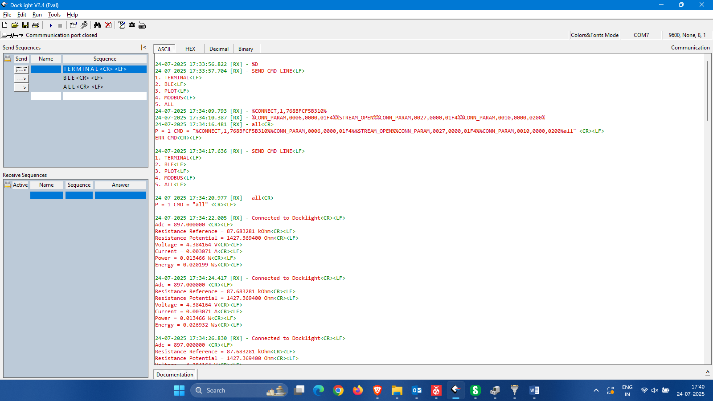**TERMINAL DOCKLIGHT**
15. 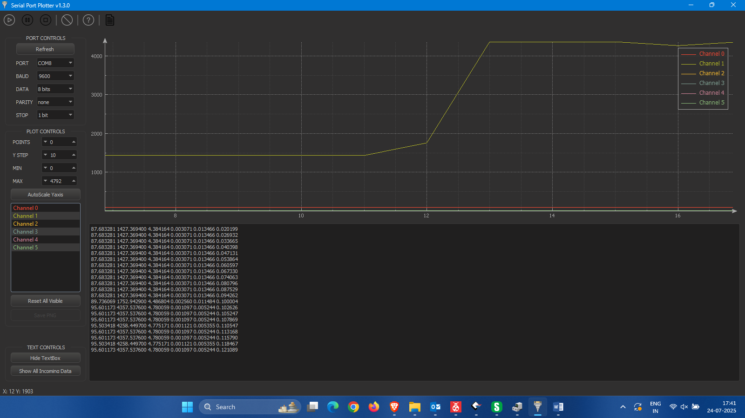**zSERIAL PORT PLOTTER**
16. 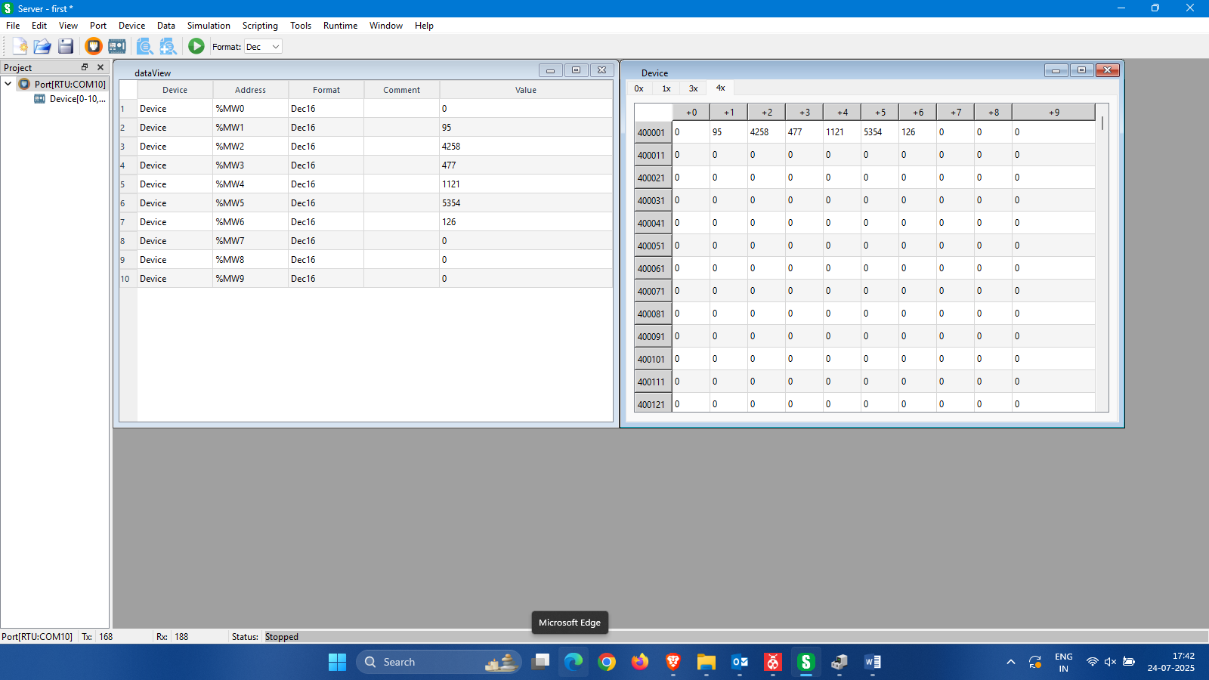**MODBUS SERVER**
17. **BLUETOOTH**

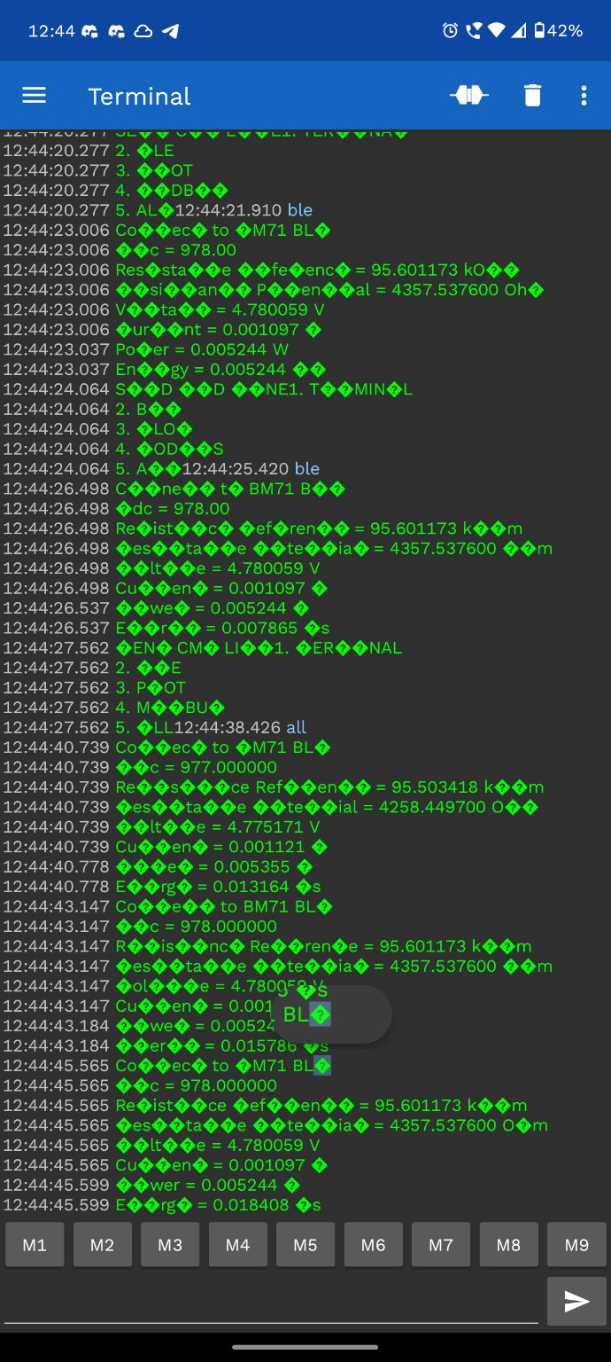

1. **FILES MANAGEMENT**
2. Main.c
3. Main.h
4. USART.c
5. USART.h
6. State Machine.c
7. State Machine.h
8. MODBUS.c
9. MODBUS.h
10. ADC.c
11. ADC.h

## **FUTURE SCOPE**

1. Integration with wireless communication (BLE, Wi-Fi)
2. Adding graphical user interface for live plots
3. Expanding to 3-phase energy monitoring
4. Logging data to SD card or cloud server
5. Enhancing accuracy using calibration techniques